MATH 213 – Homework 10
- The scatterplot shows the relationship between socioeconomic status measured as the percentage of children in a neighborhood receiving reduced-fee lunches at school (lunch) and the percentage of bike riders in the neighborhood wearing helmets (helmet). The average percentage of children receiving reduced-fee lunches is 30.833% with a standard deviation of 26.724% and the average percentage of bike riders wearing helmets is 30.883% with a standard deviation of 16.948%.

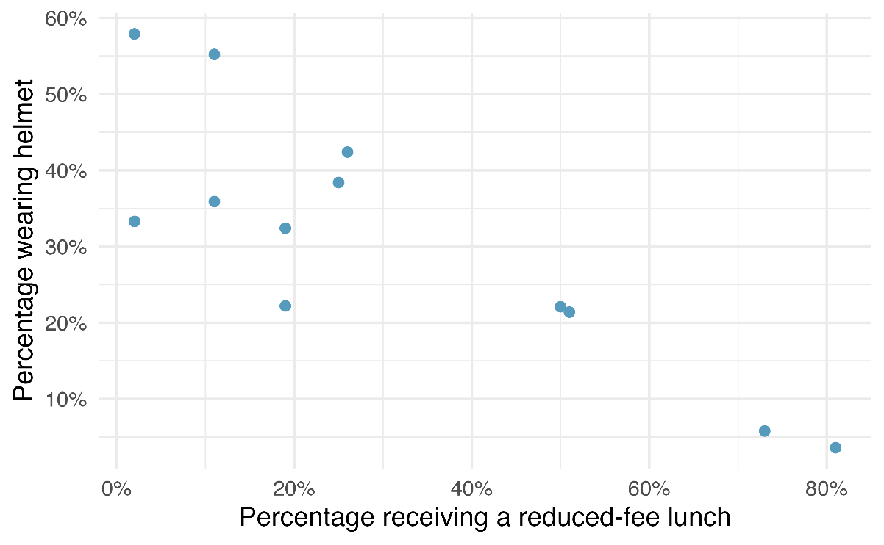
- What are the cases for this study? (Hint: What does each dot in the scatterplot represent?)

- What are the variables that are recorded about the cases? Classify each as numerical or categorical.

- Write a description of the relationship in the scatterplot. Remember the THREE key features that must be addressed, speak in context, and remember GEE.

- Back on Homework 6, you considered a dataset from the 2017 Cherry Blossom Run. The full codebook is at https://www.openintro.org/data/index.php?data=run17.

I filtered the dataset to examine the data from female contestants only. Then, I created the following model in R using “lm”.

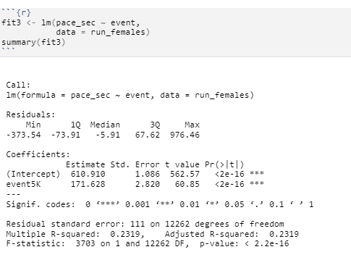

- Which variable is my predictor variable and which is my response variable, and how can you tell?

- Write an equation for the linear model using proper notation (for the field of statistics!). Don’t forget the hat! Feel free to type the word “hat” if you don’t want to bother with the equation editor. If you use variables like x and y, be specific about what x and y represent in this situation.

- Write a sentence of interpretation for each of the coefficients (slope and intercept) in the model. Write your sentences in context, rounding numbers as appropriate and using proper units.

- What is the R^2 value? Interpret that R^2 value in context.

